**Create a fantasy cricket app**

**Language/Framework**

Python/Django

**Explanation**

Fantasy cricket app is an app where users can create teams by picking players from different countries. Once a team is formed each player is awarded scores based on how he performed in the real match. The user whose team scores the highest score in the whole tournament wins.

**Users in the app**

There are 2 types of users in the app

1. The admin user, who will set up the players and their countries. The players setup by admin will be available for normal users
2. The normal users, who will be playing the game.

Users log in to the app using their email address (you will have to modify the default django user)

**The Admin User**

Admin user is created using the *createsuperuser* command.

**Normal User**

* Normal user is created using the signup process.

**Screens in the App**

**Landing page**

This is the very first page of the app. It has 2 options

1. Sign in form
2. Link to sign up page

**Sign up page**

The user can create a new account using the sign up form. He should be able to create a new account by using just the following information.

1. Email Address
2. Password
3. Retype password
4. Full name

The only validation that should be performed is that the email address should be unique.

**Home page**

Once the user signs in, he is redirected to the home page. The home page is different for normal and admin users.

When the admin user logs in to the app he has the following actions available to him

* Create new country
* Create matches
* Record performances

When the normal user logs in, he has the following actions available to him

* Create team
* View player scores
* View leaderboard

**Create New Country Page**

Only the admin user should be able to open this page. Even if the user changes the URL from the address bar he should not be able to access the page if he is not an admin user.

The purpose of this page is to create a country and its players.

The form for creating a new country should look something like the following

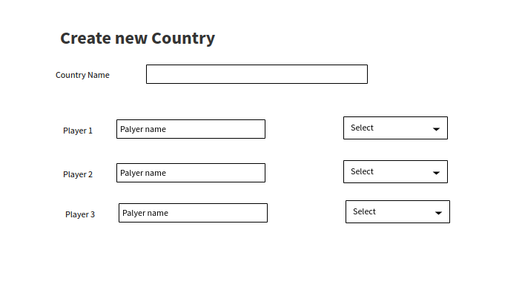

Following are the validations of the form

1. Country name should be unique
2. Although the above image shows only 3 players but form should have inputs for 15 players
3. The drop down should have the following choices, **Batsman, Bowler, All rounder and Wicket keeper**. This defines the type of a player.
4. At least 11 players should be entered, remaining 4 are optional
5. A country should have one player from each type of player. That is, you cannot make a country team with only batsmen and bowlers. But you can make a country which has 5 wicket keepers, 2 batsmen, 2 bowlers and 2 all rounders. As long as there are players from each type of the player then the country is valid.

**Create matches page**

Only the admin user should be able to open this page. Even if the user changes the URL from the address bar he should not be able to access the page if he is not an admin user.

The purpose of this page is to create matches between countries.

The form for creating a new match should look like the following

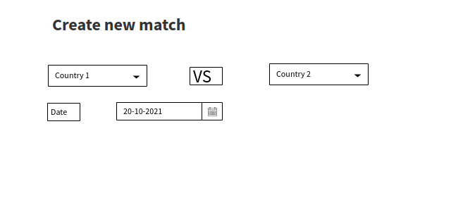

Following are the validations of the form

1. The country drop downs will show all the countries added by Create new Country page.
2. Country 1 cannot be the same as Country 2.
3. Date must be of future
4. There should not be a match between country 1 and country 2 on the same date
5. Neither of the 2 countries should be involved in a match on the same date

**Create Team page**

Only the normal user can access this page. Admin users cannot access this page even by changing the URL from the address bar. Only those normal users can access this page who have not created a team. If a normal user has already created a team, then the link on the home page should not be available. The purpose of this page is to allow the user to choose players for his team.

The form looks like the following. The form is divided into sections for Bowlers, Batsmen, All Rounders and Wicket Keepers. In front of each player, the country of the player is shown.

Following are the validations on the form

1. User should select exactly 11 players, no more no less
2. The team should contain at least 3 batsmen, 3 bowlers, 2 all rounders and 1 wicket keeper.
3. Players from at least 3 countries should be selected.

Once a team is created the user is part of the leaderboard and his score is shown on the leaderboard.

**Check against cheating**

Only matches which are played after the user has created a team are counted in his score.

For example a player creates a new team when 3 matches have already been played, so his team should not be awarded points for those matches that were played earlier. Only scores of those matches are counted which are played after the team was created.

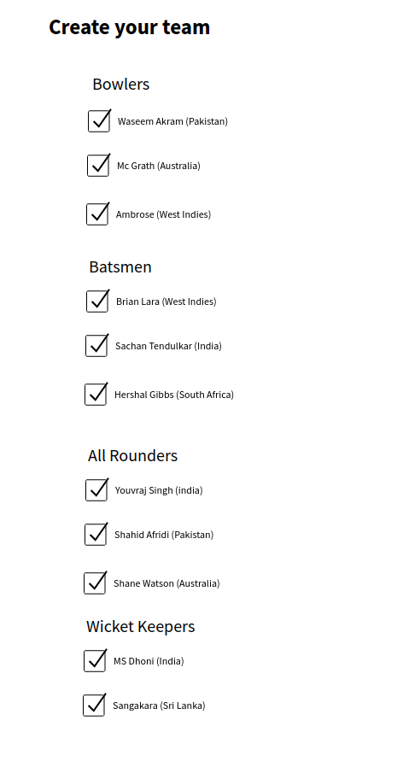

**Record Performance page**

Only the admin user should be able to open this page. Even if the user changes the URL from the address bar he should not be able to access the page if he is not an admin user.

The purpose of this page is to record how players performed in a particular match.

When the user clicks on the record performances link he is redirected to a page which shows a list of matches that have already been played. The matches that are in the future are not shown. The list is sorted by date (most recent match first). The list can have 2 type of matches

1. Matches whose performances are already recorded.
2. Matches for whom performance has not been recorded.

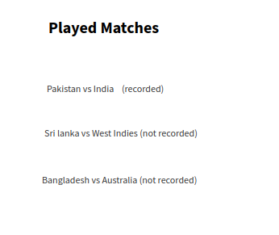

Clicking on a recorded match will show the player scores that were recorded, but these cannot be edited.

Clicking on a match which has not been recorded will open a page like the following 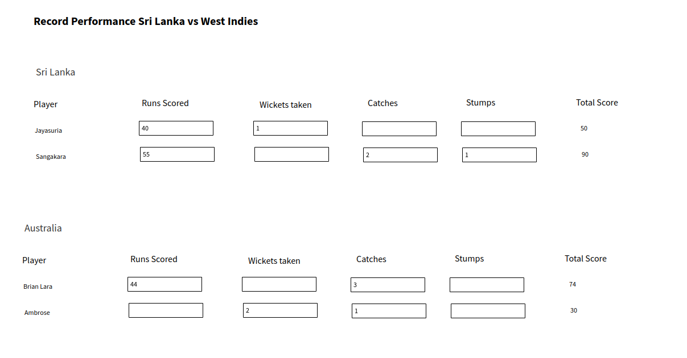

Following validations are done on the above form

1. There is one row for each player in the country, so if 15 players were added in the country in the Create New Country page then there will be 15 rows for that country.
2. The inputs that are empty are considered as zero.
3. In the inputs admin puts how the player performed in the match and the Total Score column is auto calculated
4. Only wicket keeper can do stumps.
5. Wickets taken cannot be greater than 11
6. Catches taken cannot be greater than 11
7. Stumps cannot be greater than 11

The scoring works by the following rules

1. 1 run = 1 point
2. 1 catch = 10 points
3. 1 wicket = 10 points
4. 1 stump = 15 points

As soon as the form is submitted the scores of user teams are updated depending on which players were included in a user team.

**Example:**

User A had Brian Lara in his team then his score will be increased by 74 points because Brian Lara scored 74 points in this match

User B had Sangakara and Ambrose in his team then his score will be increased by 90 + 30 = 120 points

However the award of points should take into account the Check against cheating, that is these scores will only be awarded to players whose teams were created before this match took place.

**Example:**

Lets say the Admin user had recorded that the Sri Lanka vs West Indies match will be played on 12th November, 2021. A User creates his team on 13th November, 2021 so this user will not be awarded points of this match even if the performance is being recorded on 15th November, 2021.

**View player scores page**

Only the normal user can access this page. Admin users cannot access this page even by changing the URL from the address bar. The purpose of this page is to show the users how each player in their selected team is performing.

The page will look like the following

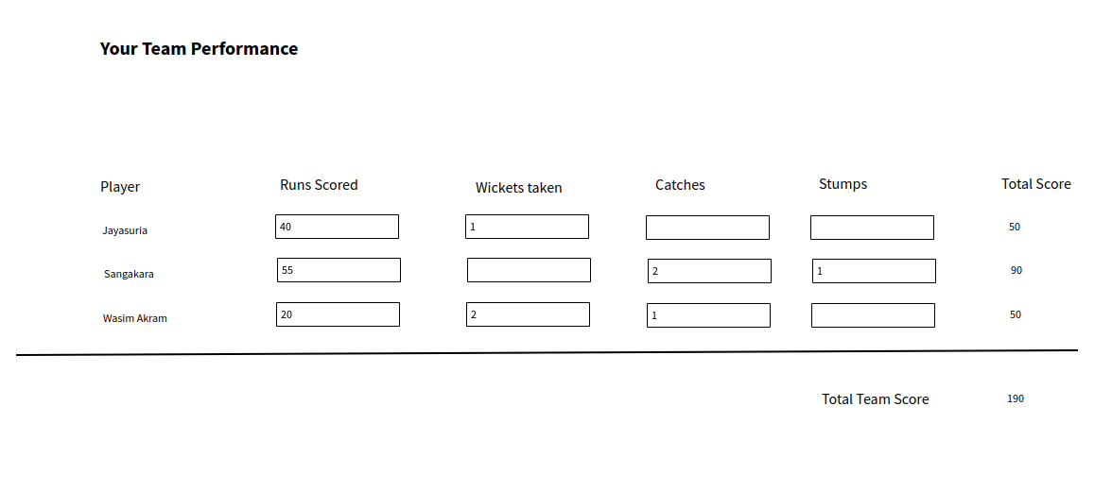

Following are the points to keep in mind

1. This page should show all the players that are in the user’s selected team, that is, there should be 11 rows for players and one final total row.
2. No value is editable.
3. Values in each column are a sum of all the performances that are recorded for this user, that is it might be possible that Wasim Akram scored 5 runs in first match and 15 runs in second match, that is why 20 runs are shown in his Runs Scored column.
4. The Total Team Score is the sum of all player scores.

**Leaderboard page**

Only the normal user can access this page. Admin users cannot access this page even by changing the URL from the address bar. The purpose of this page is to show who is winning the overall contest.

The page will look like the following

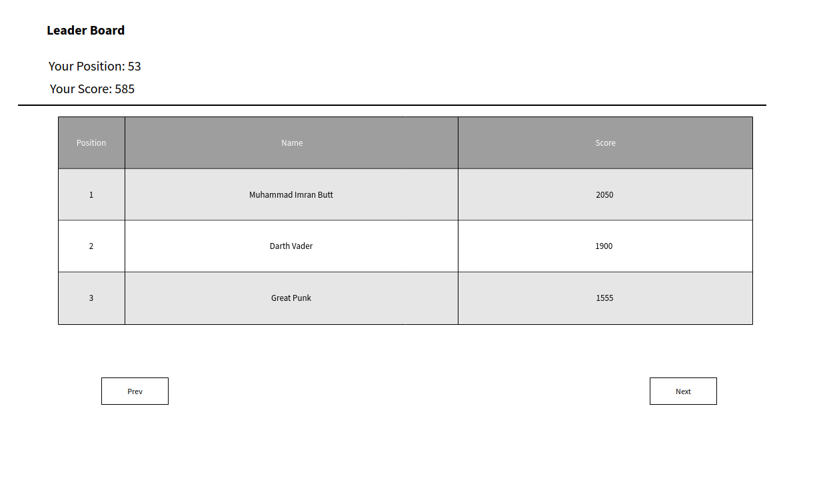

Following are some of the salient features of the page

1. The list of users is paginated, with 20 rows on each page
2. Prev button is not shown on first page
3. Next button is not shown on last page
4. Your Position shows your position in the leaderboard
5. Your Score is the total team score as calculated on View Player Scores page
6. No matter where you are on the paginated list of leaderboard, Your Score and Your Position is always shown.
7. The Position column in the table represents the position of the user.
8. The Name column displays the full name of the user.
9. The score column shows the total team score of the user.

FEEDBACK

1. The User model has been overridden but not correctly. We don’t need the username field at all, so you need to override the User model such that the username field is no longer required.
2. You have created separate apps for each new page. The maximum number of apps that I can think of is ‘authentication’, ‘super_user’ and ‘normal_user’.
3. The ‘name’ field of Country model should have unique=True.
4. The category field of Player model should have been a choice field.
5. Country_1 and country_2 fields in Matches model should have been Foreign Keys
6. In the Player_score model, there is no need for the country FK and player_name fields. Both of these values can be retrieved from the players FK field.
7. Create_new_country and create_new_country_func can be merged into a single function. We usually use ***if request.method == 'POST'***: to separate the logic between POST and GET.
8. In the create_new_country_func method, there are no validations. We don’t just rely on the validations of Front End, we also validate the request on Backend.
9. You could have used the `auto_now_add=True` in the created_at field of Country model to automatically record when a country was created.
10. In create_new_country.html the first 4 players have only one option, from Batsman, Bowler, keeper and All Rounder.
11. The best approach for this sort of form is to use django formsets.
12. Validation number 4 and 5 of Create New Country Page are not catered either in FE or BE.
13. In the create new match logic, you have assumed that the user will always select country_1 first and when the user selects the first country you try to populate the country_2 drop down. But this assumption is not correct because we don’t have control over the user. He can select whichever drop down first.
14. There is no validation that the country_1 should not have any match on the same date.